FAQ PowerOffice Go app

In english

# How do I get access to the Poweroffice Go app?

Download the app from the App store (Apple) or from Google Play (Android). Scan the QR code below.

-Log in with your Poweroffice Go username and password.

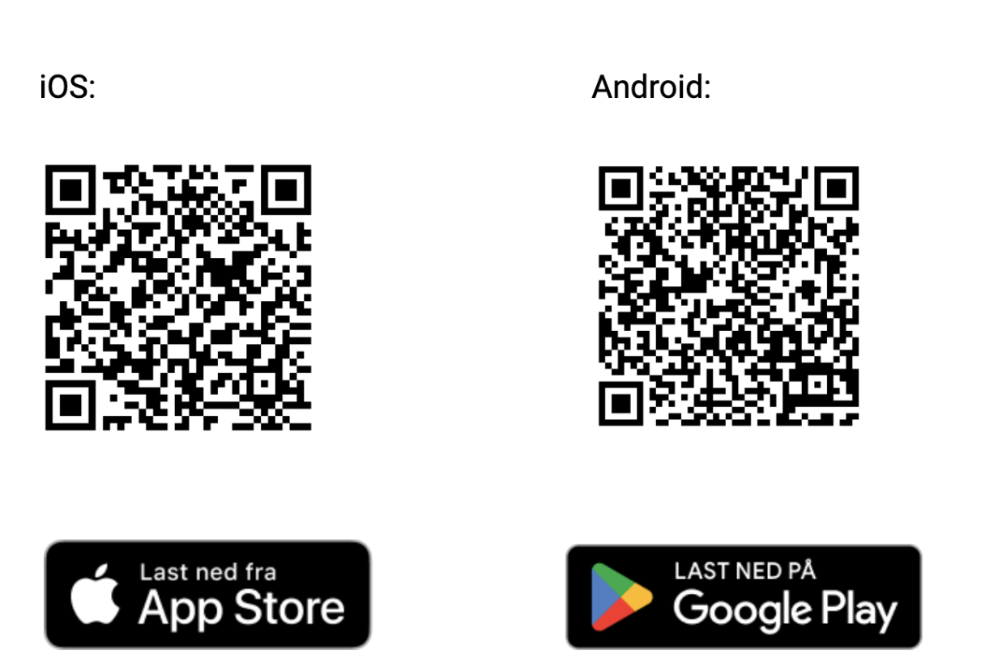

# Is there a demo app?

Contact your PowerOffice partner for access.

IOS:

Demo app is called PowerOffice EDU. You can download it only with direct link.

Here: [Download PowerOffice EDU](https://apps.apple.com/us/app/poweroffice-edu/id6450293667)

Or scan the QR code below with your mobile:



Android :

Poweroffice Go EDU is available in Google Play.

I have activated 2FA for my Poweroffice Go client. Do I need to use it when logging into the Poweroffice Go app?

No. If you only use the mobile app, you will receive an SMS code for login. If you have activated 2FA with PowerID, you are required to use this for first-time login.

I am a manager but I do not find the pending Holiday and Leave requests from my employees.

Check [here](https://support.poweroffice.com/hc/no/articles/360056459432-Ferie-og-Frav%C3%A6r-Godkjenning) that you have the correct settings for a manager.

The top right-hand corner of Holiday & Leave menu in the app has a bell showing alerts for Holiday & Leave requests that are waiting for your approval. Please note that if you have a role with access to holiday and leave: «all employees», you will see pending holiday and leave requests for all the employees in your company.

Can I reject a voucher and return it to the sender?

When you configure the "voucher approval settings" for expenses that require approval, rejected expenses are returned to the user in the app with your comment.

If the “Voucher approval settings” for expenses are not set to require approval are expenses send to Journal entry. You can return them to the user by deleting the expense from the journal. Make sure the expense was submitted through the mobile app before removing it. User will not receive an automatic notification for expenses “rejected “ this way. We recommend that you inform the user by sending a chat.

How can I send receipts or other documents to different companies?

Check that you have access to the role: Mobile: firmakort and /or Mobile: Other vouchers. This gives you access to a menu: “Voucher” and there you can send receipts and other documents to Journal entry to all the clients you have access to.

How do I get a PDF from an email into the Poweroffice app?

Direct sharing to the app:

a. When you open a PDF on your mobile, select the "Share" option or its equivalent.

b. Choose the "Poweroffice" app from the list of sharing options.

c. The documents will become available when you subsequently choose to fetch the document in the Poweroffice app. You will see an additional option called "Shared with app".

Save and fetch manually:

a. Alternatively, you can save the PDF to your "Files" or an equivalent app on your mobile.

b. Then open the Poweroffice app and choose to create an expense or trip.

c. Select "Files shared with app" to retrieve the saved PDF.

Note: For Android users, ensure that the Poweroffice app is running in the background. If it isn't, the direct sharing function might not work properly.

How do I change the app language?

The app's language follows the phone's language settings. If you want the app in a different language, you can change it yourself in the app's settings.

After you have chosen a new language, you must completely close the app and open it again.

The app is available in Norwegian, English, Swedish, and Danish.

